

*.*



|  |  |  |  |
| --- | --- | --- | --- |
|  |  | GROUP NAME: |  |
| SN | Student Names | College Id | University id |
| 1 | Anmol Poudyal | np05cp4a230006@iic.edu.np | 23049190 |
| 2 | Umar Ansari | Np05cp4a230043@iic.edu.np | 23050024 |
| 3 | Muksham Limbu | Np05cp4a230022@iic.edu.np | 23049280 |
| 4 | Pausan Chaudhari | Np05cp4a230027@iic.edu.np | 23049300 |

**Module Code & Module Title**

**CC4057NT Introduction to Information Systems**

**Assessment Weightage & Type**

**60% Group Coursework**

**Year and Semester**

**2023 Autumn**

**Assignment Due Date: Jan 31, 2024**

**Assignment Submission Date: Jan 31, 2024**

*I confirm that I understand my coursework needs to be submitted online via Google Classroom under the relevant module page before the deadline in order for my assignment to be accepted and marked. I am fully aware that late submissions will be treated as non-submission and a mark of zero will be awarded.*

Table of contents

Table of Contents

1 Introduction 1

1.1 Introduction to project 1

1.2 Goals and objective 1

1.3 Introduction to html 2

1.4 Introduction to CSS 3

1.5 Introduction to java script 4

1.6 Introduction to text editor 5

1.7 Introduction to wire framing tool 6

2 Website pages 7

2.1 Home page 7

2.2 Product page 9

2.3 About us page 12

2.4 Blog page 14

2.5 Research page 16

3 Tests 18

3.1 Tests 1: Hover effect 18

3.2 Tests 2: page links 19

3.3 Test 3: form validation 20

3.4 Test 4: Dynamic change in content 22

3.5 Test 5: Feedback form submission 25

4 Conclusion 26

5 References 27

6 Appendix 27

Home page code: 27

7 Plagiarism report 72

**Table of figures**

Figure 1: HTML logo 2

Figure 2 CSS logo 3

Figure 3: java script logo 4

Figure 4: Sublime text logo 5

Figure 5: balsamiq logo 6

Figure 6: wireframe of home page 7

Figure 7:home page 1 8

Figure 8: home page 2 8

Figure 9:home page 8

Figure 10: wireframe of the product page 10

Figure 11: wireframe of product page 11

Figure 12: wireframe of about us page 12

Figure 13:about us page 1 12

Figure 14: about us page(2) 13

Figure 15: wireframing of the blog page 14

Figure 16: blog page 15

Figure 17:wireframe of the research page 16

Figure 18:research page 17

Figure 19: image before hover 18

Figure 20: image after the hover 18

Figure 21:before the click of the link 19

Figure 22: after the click (test 2) 20

Figure 23: filling all the form test 3 21

Figure 24: clicking to next 21

Figure 25: result after clicking to next 21

Figure 26: clicking to next without filling all the forms (test 3) 22

Figure 27: result after clicking next without filling all the details (test -3) 22

Figure 28: filling the form test 4 23

Figure 29: filling the form 2 test 4 23

Figure 30: clicking on summarize order test 4 24

Figure 31: the inputs were displayed test 4 24

Figure 32: filling the form and clicking submit test 5 25

Figure 33: the page was refreshed and pop up alert was shown test 5 26

Table of Tables

Table 1: test one experiment 18

Table 2: test 2 experiment 19

Table 3: test 3 experiment 20

Table 4 dynamically changing the web experiment 22

Table 5: Feedback form submission experiment 25

# Introduction

## Introduction to project

Before we introduce you to the project we would to clear what website actually is. A website is a collection of linked pages. A website is created for numbers of reasons by a group or company or even an individual. Websites can be of any types from e-commerce websites to news, education and even social-networking websites

In this course work we have created an e-commerce website that is named as Go print. Go print is a user-friendly website that could be used to buy different types of branded as well as normal printers. Go print consists of five inter-linked webpages that are Home page, product page, blog page, research page and about us page. Here home page includes the overall view of the website where you can buy different printer products whereas in blog can give you lots of information on how printing technology has impacted our daily life and business the about us page has the information of our teams who have worked really hard to make this project a success lastly in research page we have included all the comparison of the website we have compared our website with. We have tried to make the website user friendly as possible.

In this website we have used HTML to structure the website pages, CSS to add Style to it and have used Java Script to add some functions to it.

## Goals and objective

* To design a fully functional website
* To learn basic about the front end
* To learn the use of html java script and css properly
* Make full use of college resources
* Implementation of proper indentation

## Introduction to html



Figure 1: HTML logo

Html full formed as hyper-text markup language is a markup language that is used to design a webpage. Html can also be termed as a skeleton of a web page as HTML uses tags that define elements within an element. There are lots of misconception about the HTML being a programming language but rather it is a standard markup language which is used to structure the contents(text) of a webpage. While displaying to the user a browsers displays only contents that are enclosed within a tag. If you wonder what tags are it is a thing that defines element within a document.

## Introduction to CSS



Figure 2 CSS logo

CSS full formed as cascading style sheet is a type of a style sheet program that is used to style the HTML documents. For example, if you want to style a button according to you and place in in accordance to your comfort you can use CSS to do such task. In this course work we have used types of CSS that are internal, external and inline. Where inline CSS are written within a tag of html whereas the internal css are used within a document and are written inside style tags similarly external CSS are written in different document that has extension .css.

## Introduction to java script



Figure 3: java script logo

Java script is a light weighted programming language which is specially used to make a website more interactive to a user. JS or java script is case sensitive language that runs on browser. For example, if you click on a certain button in a webpage it does some work that work is done by java script. Java script can also be used to change the html or css elements of a certain web. Java script is usually used by developers to build diff web applications, games etc. Java script is written in two different places that are internal which is written inside a script tag in document itself whereas external is written in different document file that has extension .js.

In this course work we have used lots of java scripts for form validation, change the location and for popup.

## Introduction to text editor



Figure 4: Sublime text logo

Text editors are the computer programs that are used to edit, open, view, change and open the files that has plain text. Among the many text editor people used notepad, visual studio code, sublime text is the most popular among them.

Sublime text is one of the powerful text editors in the concurrent world. Due to its simplified UI it is preferred by most of the developers in this developing industry. It has minimal interface where we can customize it with dozen different color (Slim, 2023)

In this course work we have used sublime text as text editor and have used extension package like live preview constantly monitor our changes and also to view our progress.

## Introduction to wire framing tool



Figure 5: balsamiq logo

Wireframing is a process to design your website page before the coding part starts. It can also be said that it’s a design of a page at structural level. It is generally used to layout content as well as functionality on a page according to the users need. (experienceux, 2024). There are lots of wireframing tools that could be used to design a websites like balsamiq, canva, figma etc.

Balsamiq is one of the popular wireframing tool which is used to create digital sketching of a website according to you. It is usually used during the brain strumming for the idea of UI in web page.

In this coursework we have used balsamiq for the design of our website. It was relatively easy to use than other tools due to its variety of designing materials.

# Website pages

Go print consists of 5 different pages that are home, product, about us, blog and research page. All these pages are interlinked to work together to give user/customer a smooth experience to buy their need products

## Home page

This page is the main page of our website among other pages. This page gives you the overview of what to expect from our website. As from the users perspective this page is like a first impression to us so we have attempted the home page be more attractive as possible. We have included offers and information on products as well as a top products menu which will give user more convenient way to explore the common products. We have aso included information of the brands which is sold by Go print.

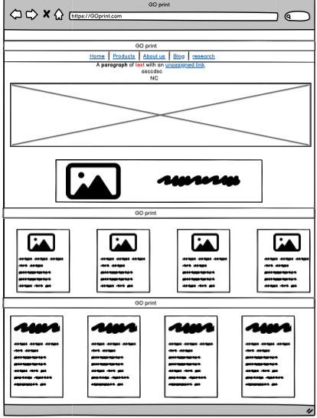

Figure 6: wireframe of home page

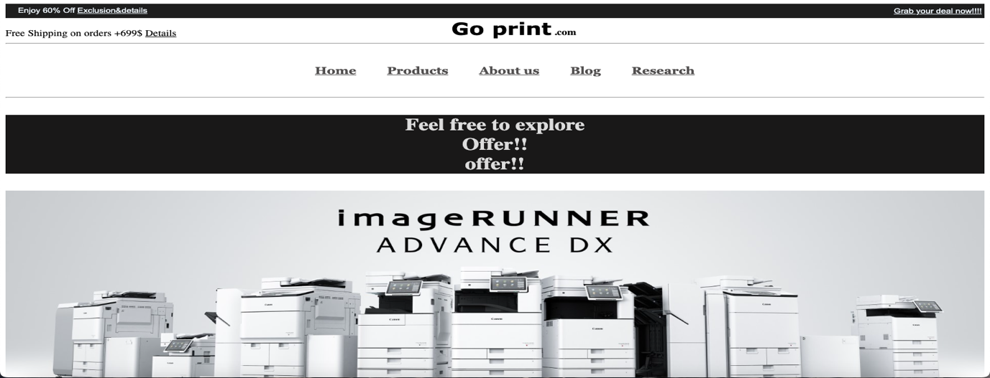

Figure 7:home page 1

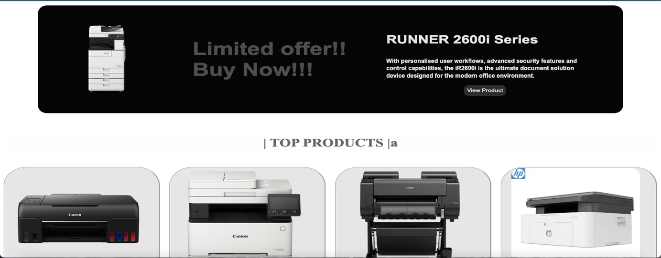

Figure 8: home page 2

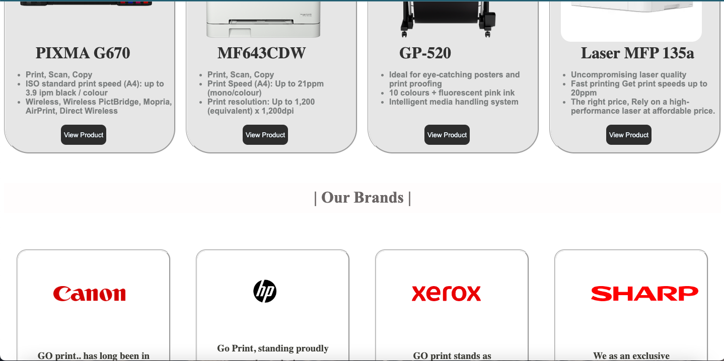

Figure 9:home page

## Product page

In this page we have included all the products available at our website. This page can be explored by the user to start the buying process. In this page we have tried to give information about the product as much as possible and also have included genuine price of the products i.e. printer. Here to start the buying process a user can click the buy now button which will take you to the form section where you will complete the buying process. We have tried to give a user a smooth browsing experience by using high quality image and important descriptions.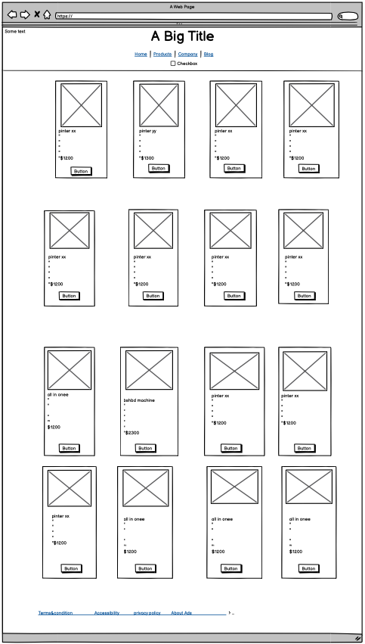

Figure 10: wireframe of the product page

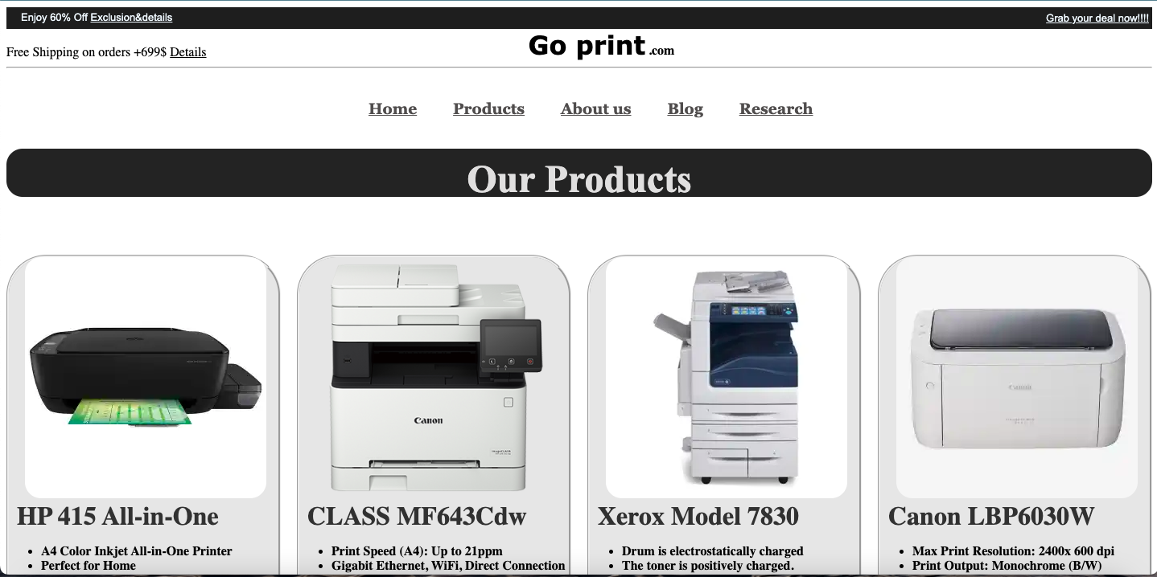

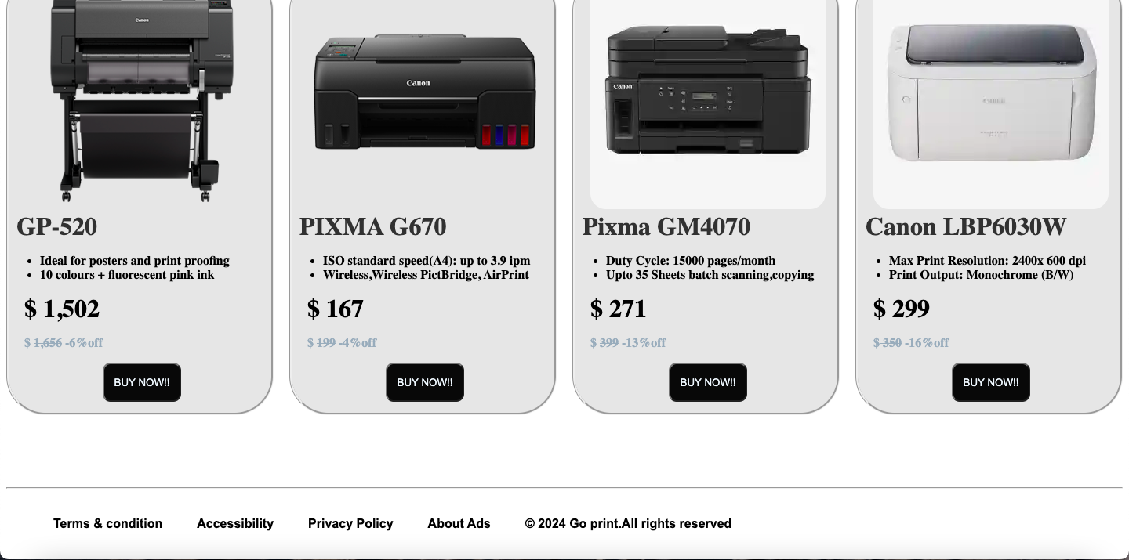

Figure 11: product page

## About us page

About us page gives a shot information of our team members who have worked tirelessly for this webpage. This page also gives a shot description of our page named also our slogans and motives. And in this page a user can also give feedbacks to us through a message box

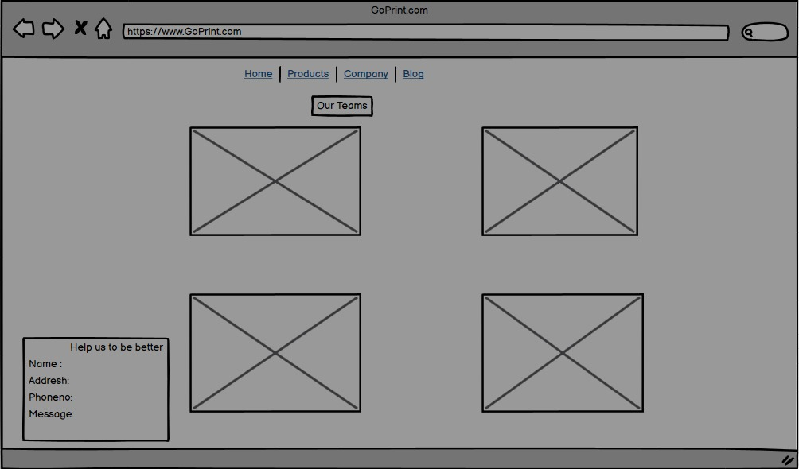

Figure 12: wireframe of about us page

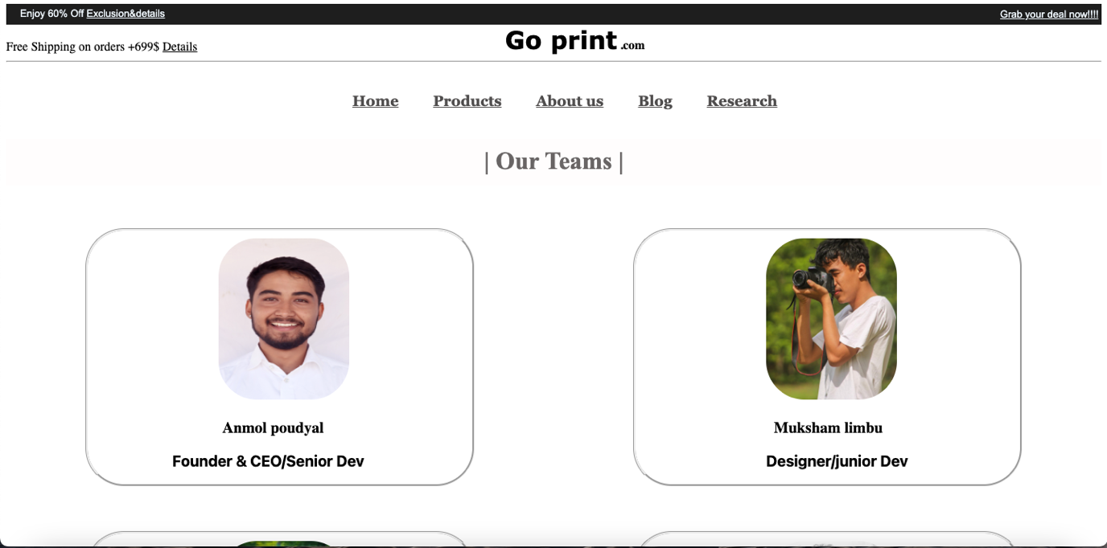

Figure 13:about us page 1

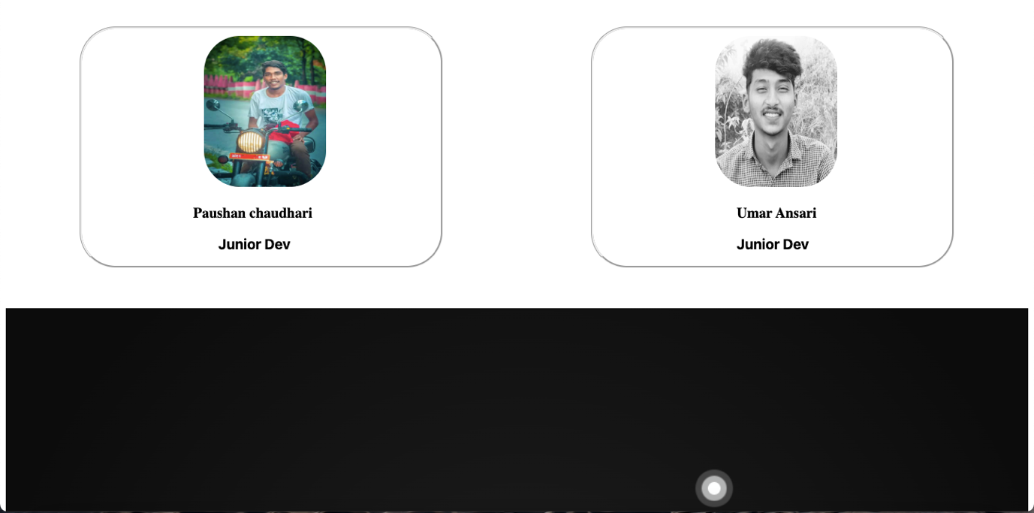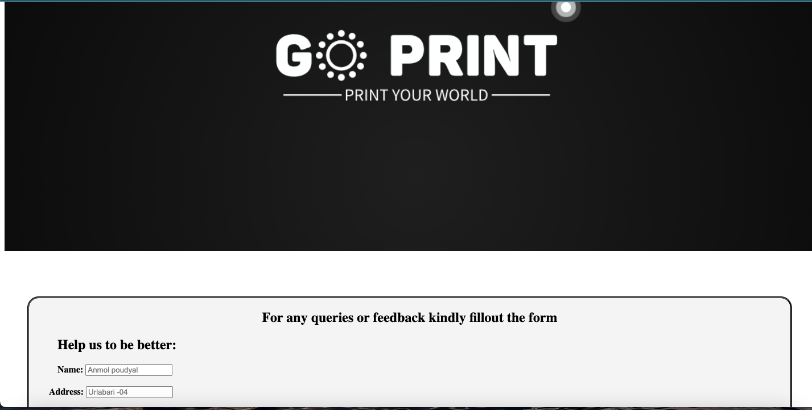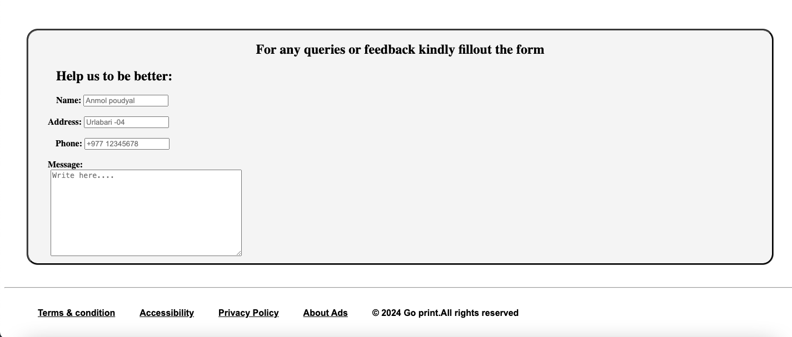

Figure 14: about us page(2)

## Blog page

Blog page of this website is one main page because we have included information about the current technological impact of on our daily life and in the business. It is supposed to be updated per month if it goes for the production. Here you can get lots of information about the new technological development and impact of it. Here we have tried to make this page more informatic. Blog page is one of the simplest pages we have created in website where it does not have any functionality other than a scroll button.

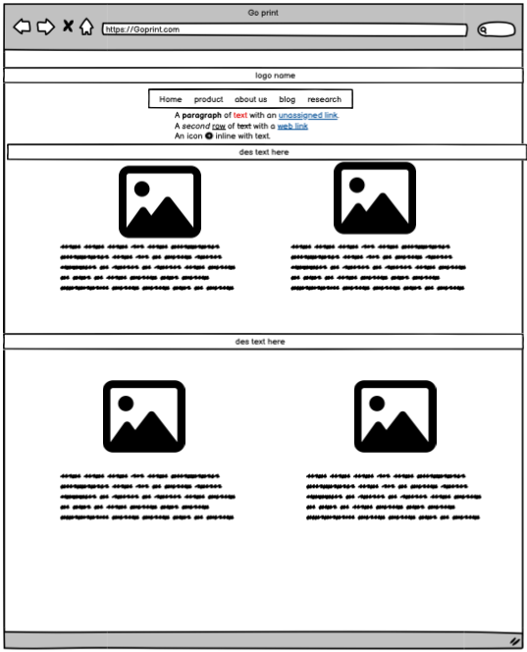

Figure 15: wireframing of the blog page

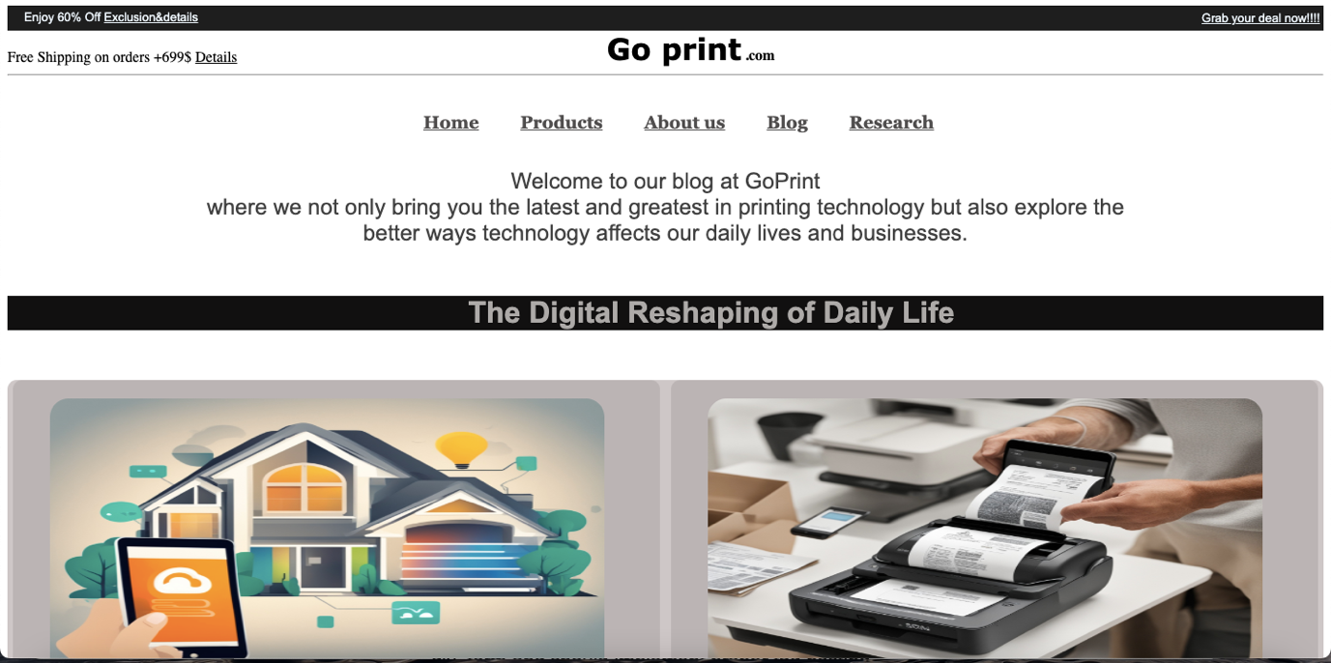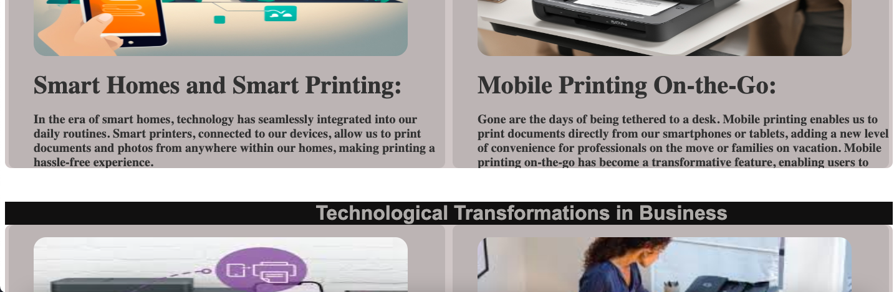

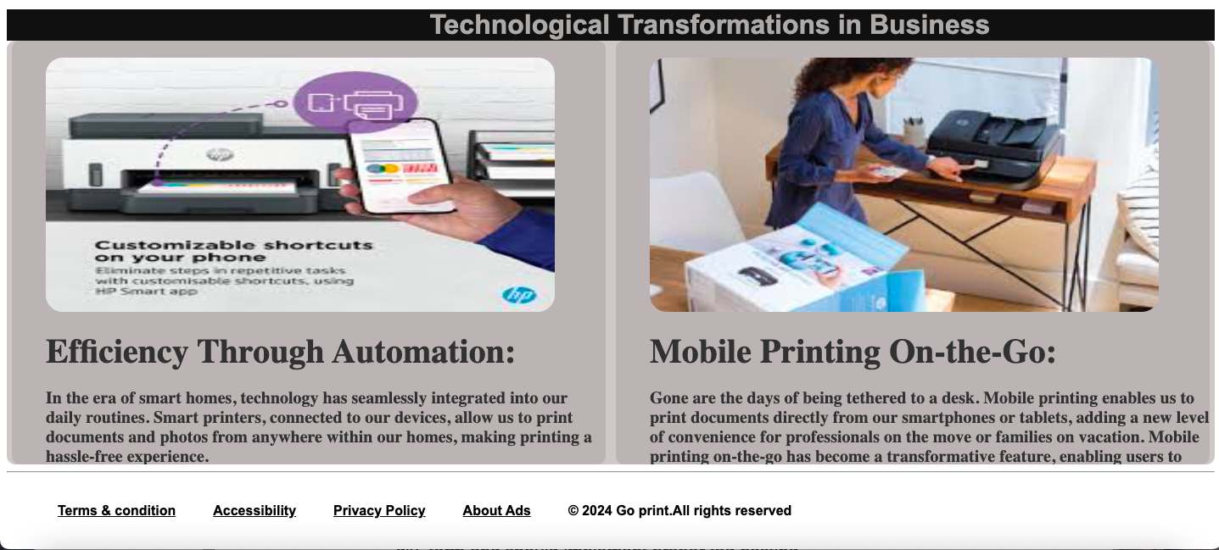

Figure 16: blog page

## Research page

In the research page we have compared our website with the other websites which we have taken as a reference during our research. Among the tons of websites presents in the browser we have taken in count for the few websites that really inspired us. Although all the pages are the result of our team’s creativity some of the sections might be similar.

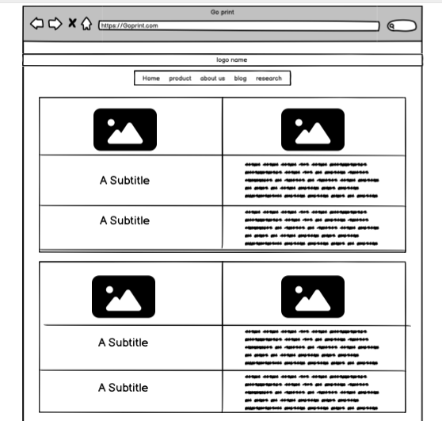

Figure 17:wireframe of the research page

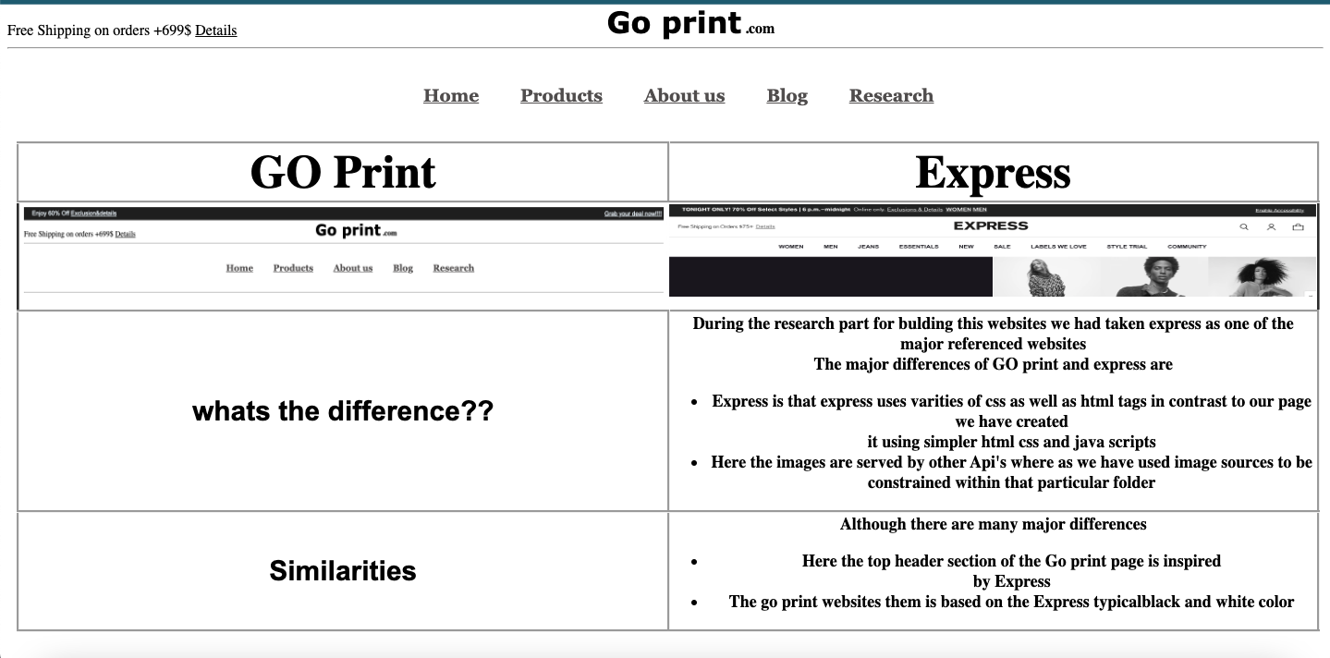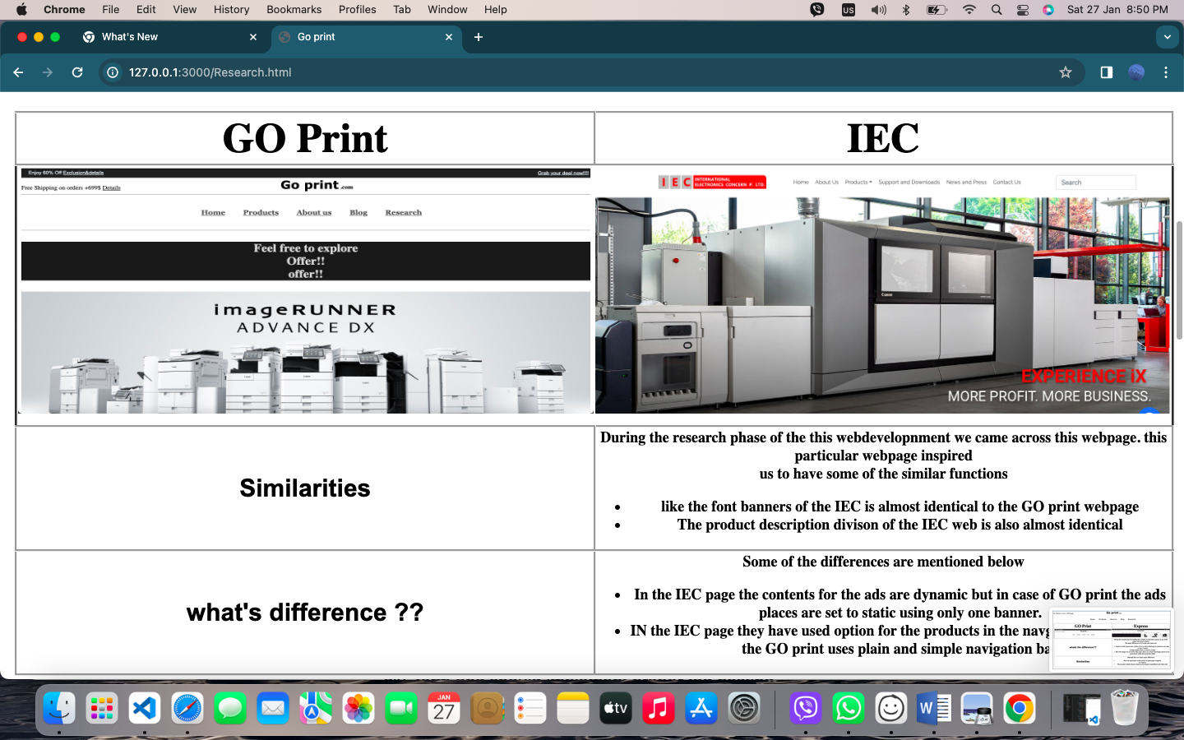

Figure 18:research page

# Tests

## Tests 1: Hover effect

Table 1: test one experiment

|  |  |
| --- | --- |
| Objective | To check the hover of navigation bar |
| Action | The cursor was taken to navigation bar |
| Expected result | The font of the navigation bar element must become enlarge with suitable size |
| Actual result | The font of the navigation bar element was enlarged with suitable size |
| Conclusion | Test was successful |

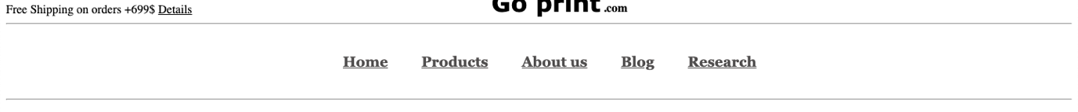

Figure 19: image before hover



Figure 20: image after the hover

## Tests 2: page links

Table 2: test 2 experiment

|  |  |
| --- | --- |
| Objective | To check the link between pages |
| Action | The cursor was taken to the navigation bar and clicked on the text where research page was written |
| Expected result | After the click page must get redirected to the research page. |
| Actual result | The page got redirected to the research page and the research page was opened. |
| conclusion | The test of the page links was successful. |

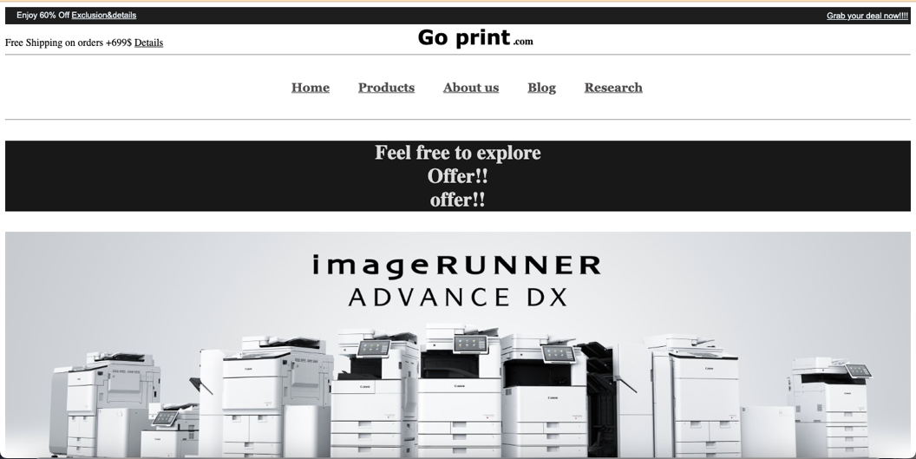

Figure 21:before the click of the link

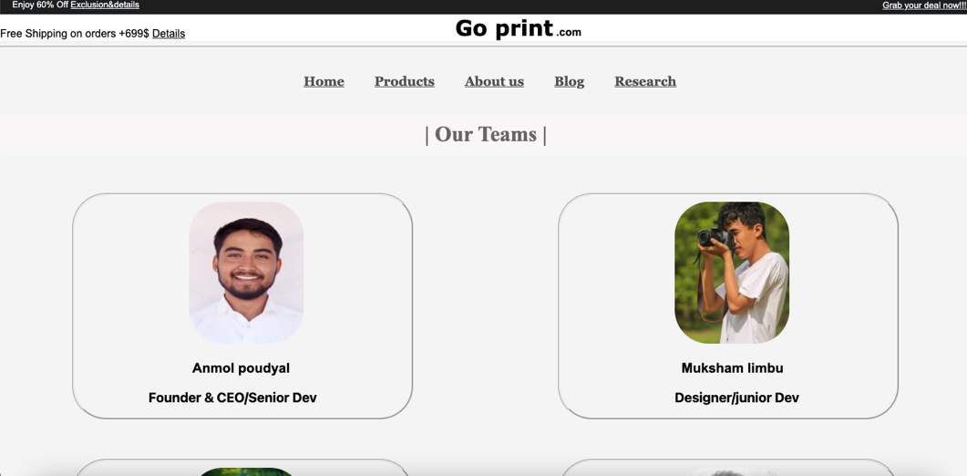

Figure 22: after the click (test 2)

## Test 3: form validation

Table 3: test 3 experiment

|  |  |
| --- | --- |
| Objective | Testing the form submission and validation |
| Action | 1.All details were filled.  2.missed filling one detail. |
| Expected result | 1.when the form was clicked to next after filling all the details the page must be taken to next page. 2. When the form was clicked to next after missing one detail suitable alert message must be displayed |
| Actual result | 1.when the form was clicked to next after filling all the details the page was taken to next page. 2. When the form was clicked to next after missing one detail suitable alert message was displayed |
| conclusion | Testing the form validation was successful |

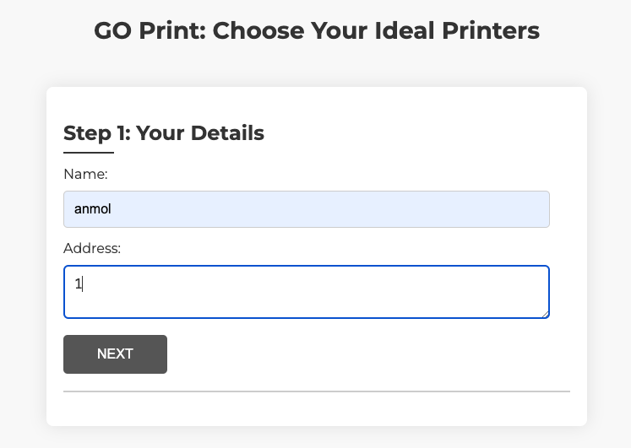

Figure 23: filling all the form test 3

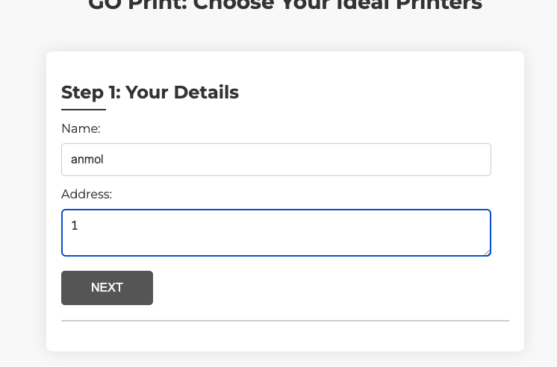

Figure 24: clicking to next

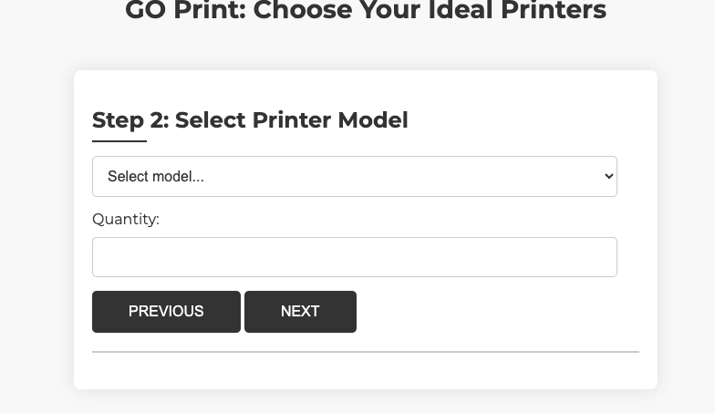

Figure 25: result after clicking to next

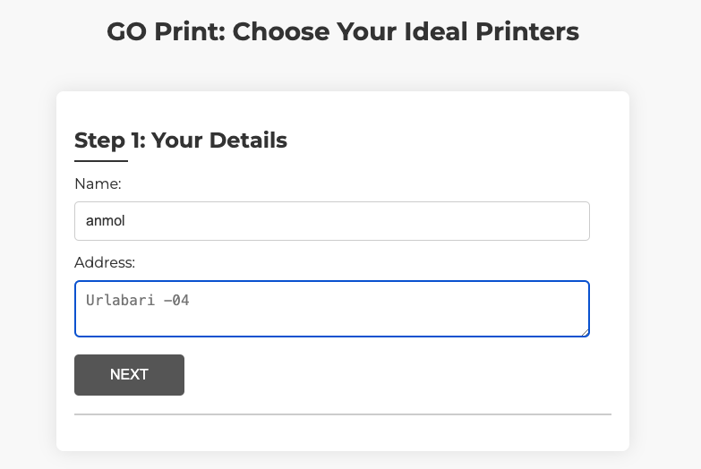

empty

Figure 26: clicking to next without filling all the forms (test 3)

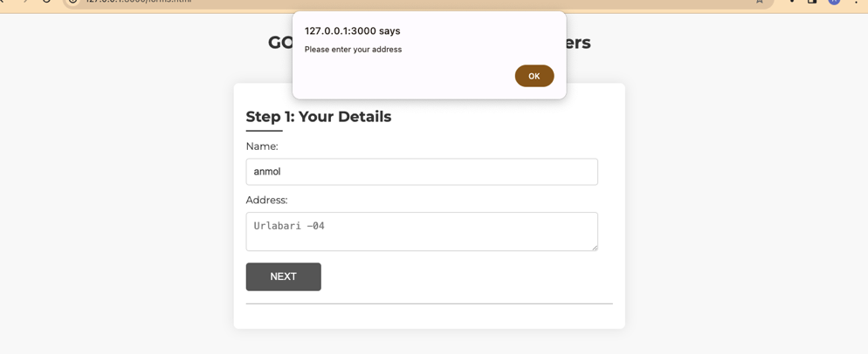

Figure 27: result after clicking next without filling all the details (test -3)

## Test 4: Dynamic change in content

Table 4 dynamically changing the web experiment

|  |  |
| --- | --- |
| Objective | To change the content of form page dynamically |
| Action | 1.The forms were filled with respective data and was clicked to summarize order |
| Expected result | After the summarize order button will be clicked the empty spaces must be filled automatically with the previously entered data by the user |
| Actual result | After the summarize order button was clicked the empty spaces in the order summary section were filled with the users input data |
| Conclusion | The test was successful |

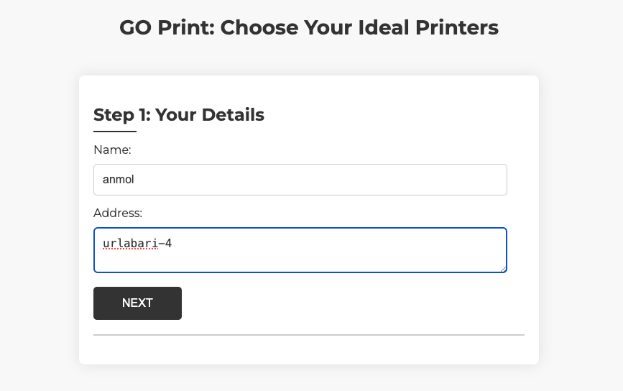

Figure 28: filling the form test 4

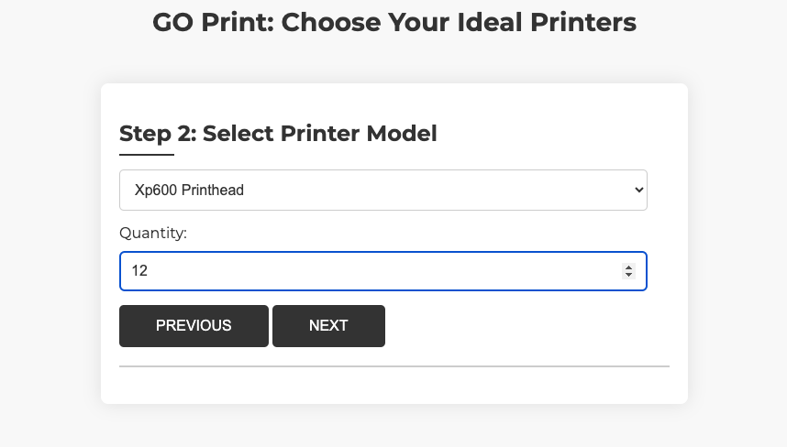

Figure 29: filling the form 2 test 4

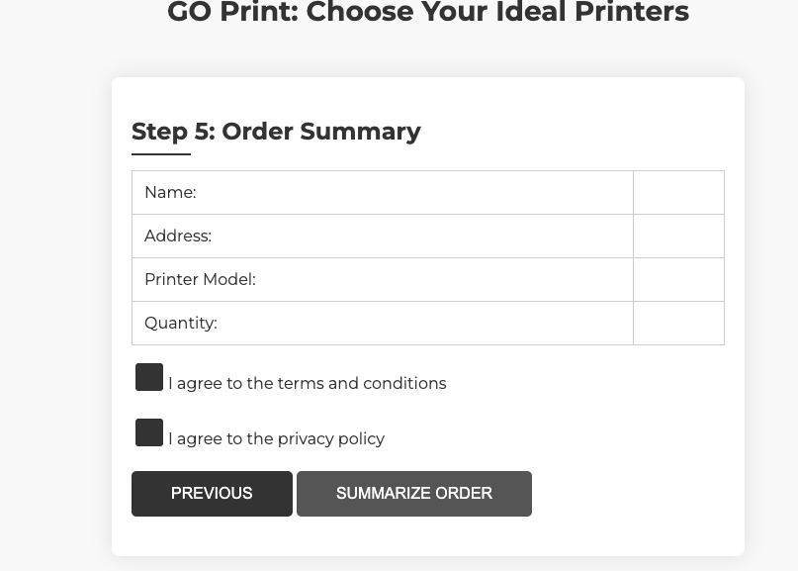

Figure 30: clicking on summarize order test 4

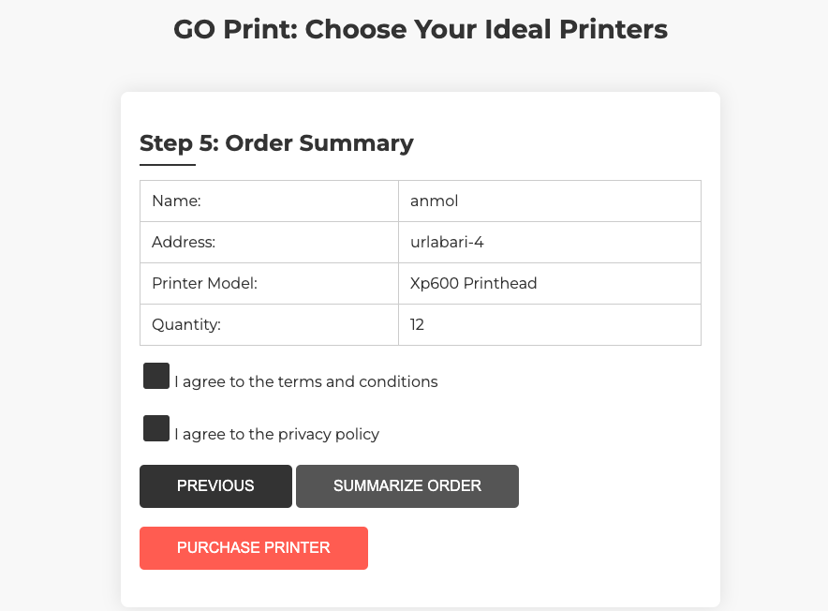

Figure 31: the inputs were displayed test 4

## Test 5: Feedback form submission

Table 5: Feedback form submission experiment

|  |  |
| --- | --- |
| Objective | To submit the form |
| Action | The form requirements were properly filled and the submit button was clicked |
| Expected result | After the form will be filled and the button were to be clicked the form must show the pop up with alert message |
| Actual result | After the form was be filled and the submit button was clicked the form was submitted and alert was shown |
| conclusion | The test was successful |

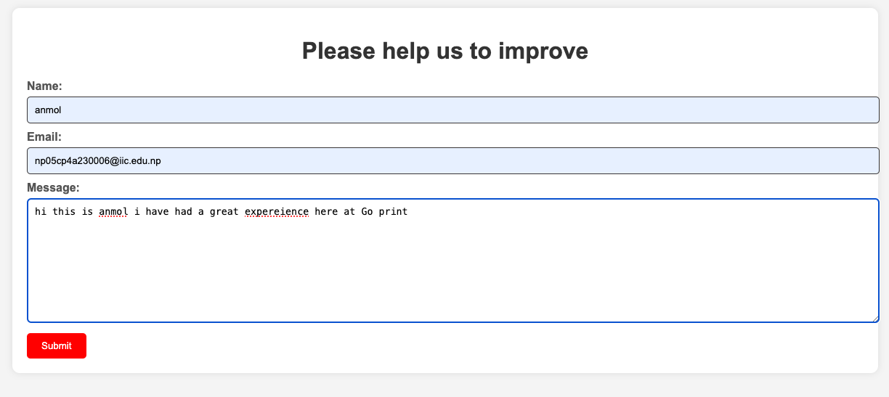

Figure 32: filling the form and clicking submit test 5

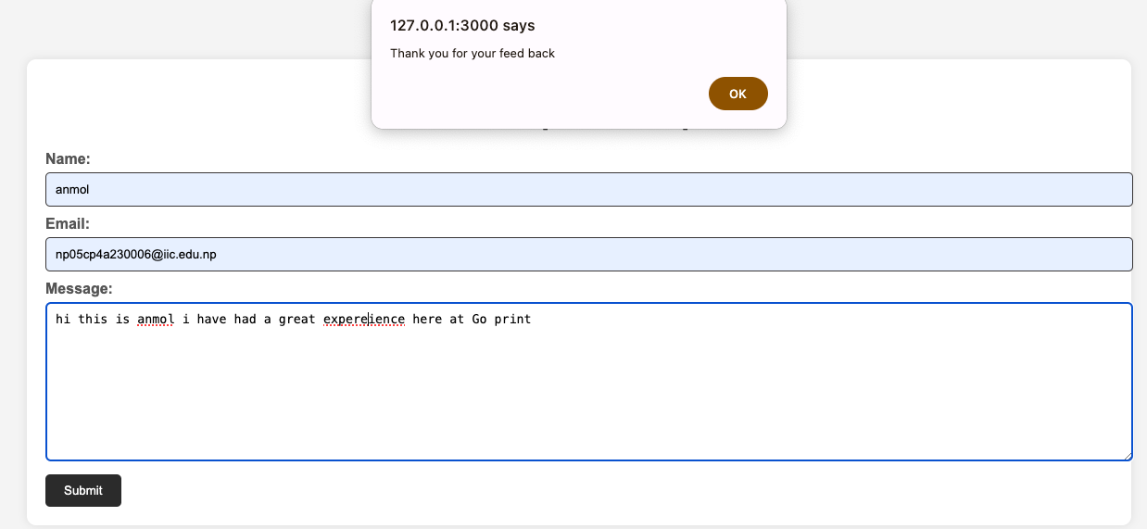

Figure 33: the page was refreshed and pop up alert was shown test 5

# Conclusion

To conclude with this coursework has taught us a lot of different things like how each and every team member is equally necessary and how to work as a team. For the better out comes we stayed InTouch with each other and also learned how to learn from each other’s mistake beside that we have also learned a lots of thing coding wise we have learned what HTML is how its being used and how do we use it other than that we have also learned styling through different css elements and also we have got a chance to learn different programming language that is java script. Through this coursework we have also learned a basic knowledge about front end and how front-end dev works.

Overall this project helped us to grow our vocational and also developing skills.

# References

experienceux, 2024. *experienceux.co.uk/faqs.* [Online]   
Available at: https://www.experienceux.co.uk/faqs/what-is-wireframing/

Slim, X., 2023. *softonic.* [Online]   
Available at: https://sublime-text.en.softonic.com/mac#:~:text=Sublime%20Text%20is%20a%20free,a%20variety%20of%20programming%20languages.

# Appendix

## Home page code:

<!DOCTYPE html>

<html lang="en">

<head>

<meta charset="UTF-8">

<meta http-equiv="X-UA-Compatible" content="IE=edge">

<meta name="viewport" content="width=device-width, initial-scale=1.0">

<link rel="stylesheet" href="Style.css">

<title>Go print </title>

<style>

/* for the fooetr*/

footer {

margin-bottom: 0px;

}

footer ul {

background: rgb(255, 255, 255);

}

footer li {

display: inline-block;

padding: 20px;

font-family: Arial, Helvetica, sans-serif;

font-size: small;

}

/* for the first main paragraph*/

.main_page_firs_paragraph {

text-align: center;

font-size: xx-large;

background: #191818;

color: rgba(255, 255, 255, 0.849);

}

.container_ads {

background-color: rgb(6, 5, 5);

margin-left: 75px;

margin-right: 75px;

justify-content: space-between;

display: flex;

border-radius: 20px;

height: 300px;

align-items: center;

}

/* for the ads part after the main static image */

.right_of_ads {

justify-content: center;

color: rgb(233, 230, 230);

line-height: 1.3;

margin-right: 100px;

}

.left_of_ads {

margin-left: 50px;

}

.button_product {

border-style: inherit;

height: 30px;

border-radius: 10px;

margin-left: 170px;

background-color: rgb(45, 45, 45);

color: aliceblue;

}

.middle_of_ads {

color: rgb(79, 77, 77);

font-family: Arial, Helvetica, sans-serif;

font-size: 25px;

}

.top_brand_container {

background-color: white;

display: flex;

justify-content: space-between;

height: 510px;

overflow: hidden;

}

.top_brand {

height: 500px;

width: 335px;

border-style: groove;

border-radius: 50px;

background-color: rgba(35, 34, 34, 0.114);

}

.top_pic {

height: 280px;

width: 280px;

margin-left: 20px;

}

.top_brand_desc li {

color: rgb(124, 127, 127);

font-family: Arial, Helvetica, sans-serif;

}

.button_top_brand {

border-style: inherit;

height: 40px;

border-radius: 10px;

margin-left: 70px;

background-color: rgb(45, 45, 45);

color: aliceblue;

}

</style>

</head>

<body>

<!--for the top presentation and ads space and offer info-->

<div class="header_container">

<div class="left_header">

Enjoy 60% Off <u>Exclusion&details</u>

<span class="right_header"><u>Grab your deal now!!!!</u></span>

</div>

</div>

<div class="logo_section">

<div class="logo_section_left">

Free Shipping on orders +699$ <u>Details</u>

</div>

<div>

<span style="font-family:Verdana, Geneva, Tahoma, sans-serif;font-size:xx-large;"><b>Go print</span>

.com

</div>

</div>

<hr>

<nav>

<ul>

<li><a href="index.html">Home</a> </li>

<li><a href="Products.html">Products</a></li>

<li><a href="aboutus.html">About us</a></li>

<li><a href="Blog.html">Blog</a></li>

<li><a href="Research.html">Research</a></li>

</ul>

</nav>

<hr>

<!-- this is for the main section -->

<p class="main_page_firs_paragraph"> Feel free to explore <br>Offer!!<br>offer!! </p>

<main>

<div>

<img src="homepic/banner.jpeg " style="width: 100%;">

</div>

<br>

<!--below div is for the ads that is showing limited offer and it shows the right section and the left section-->

<div class="container_ads">

<div class="left_of_ads">

<img src="homepic/ads.jpg" style="height: 200px; width: 200px;">

</div>

<div class="middle_of_ads">

<h1>Limited offer!!<br> Buy Now!!!</h1>

</div>

<div class="right_of_ads">

<h2 style="font-size: xx-large; font-family: Arial, Helvetica, sans-serif;">RUNNER 2600i Series</h2>

<p style="font-family: 'Franklin Gothic Medium', 'Arial Narrow', Arial, sans-serif;">With personalised

user workflows,

advanced security features and <br> control capabilities, the iR2600i is the ultimate document

solution<br> device designed for the modern office environment.</p>

<button onclick="redirect()" class="button_product" > View Product</button>

</div>

</div>

<br><br><br>

<!--now section for top Products-->

<div class=brand>

<h> | TOP PRODUCTS |</h>a

</div>

<br>

<br>

<!--product 1-->

<div class="top_brand_container">

<div class="top_brand">

<img src="top_sell/home_top brand.png" class="top_pic">

<h style="margin-left: 60px;font-size: xx-large;color: rgb(49, 49, 49);">PIXMA G670</h>

<ul class="top_brand_desc">

<li>Print, Scan, Copy</li>

<li>ISO standard print speed (A4): up to 3.9 ipm black / colour</li>

<li>Wireless, Wireless PictBridge, Mopria, AirPrint, Direct Wireless</li>

<br>

<button class="button_top_brand" onclick="redirect()"> View Product</button>

</div>

<!--product 2-->

<div class="top_brand">

<img class="top_pic" src="top_sell/home_pic2.png">

<h style="margin-left: 60px;font-size: xx-large;color: rgb(49, 49, 49);">MF643CDW</h>

<ul class="top_brand_desc">

<li>Print, Scan, Copy</li>

<li>Print Speed (A4): Up to 21ppm (mono/colour)</li>

<li>Print resolution: Up to 1,200 (equivalent) x 1,200dpi</li>

<br>

<button class="button_top_brand" onclick="redirect()"> View Product</button>

</div>

<!--product 3-->

<div class="top_brand">

<img class="top_pic" src="top_sell/home_pic3.png">

<h style="margin-left: 60px;font-size: xx-large;color: rgb(49, 49, 49);">GP-520</h>

<ul class="top_brand_desc">

<li>Ideal for eye-catching posters and print proofing</li>

<li>10 colours + fluorescent pink ink</li>

<li>Intelligent media handling system</li>

<br><br>

<button class="button_top_brand" onclick="redirect()"> View Product</button>

</div>

<!--product 4-->

<div class="top_brand">

<img class="top_pic" style="border-radius: 20px;" src="top_sell/home_pic4.jpg">

<h style="margin-left: 60px;font-size: xx-large;color: rgb(49, 49, 49);">Laser MFP 135a</h>

<ul class="top_brand_desc">

<li>Uncompromising laser quality</li>

<li>Fast printing Get print speeds up to 20ppm</li>

<li>The right price, Rely on a high-performance laser at affordable price.</li>

<br>

<button class="button_top_brand" onclick="redirect()"> View Product</button>

</div>

</div>

<!--for the brand description-->

<br><br><br>

<div class=brand>

<h> | Our Brands |</h>

</div>

<br>

<br><br><br>

<!--for the types of brand availabe each div has one product-->

<div class="brand_container">

<!--1st brand-->

<div class="brand_box">

<img src="homepic/brand_img1.png" style="height: 30px;margin: 70px;"><br>

<p class="para_brand">GO print.. has long been in<br> partner ship with Canon <br>as a sole

authorised<br>

dealer for Nepal. From<br>Products ranging from <br>Laser Printer, Multi-<br>Function-Printer,<br>

Copiers, Colour Copiers,<br> Business Multi-<br>Function-Devices, Inkjet<br> Printers, Fax,

Document<br> Scanners,Graphic <br>Scanners,

Paper media<br> and Medical<br> Equipments. These<br> products have been <br>made available<br>

throughout the country.<br>

With Canon,Business <br>can be simple.

</p>

</div>

<!--2nd brand-->

<div class="brand_box">

<img src="homepic/brand_img2.png" style="height: 60px;margin-left:100px;width:80ppx;margin-top: 50px;">

<p class="para_brand" style="margin-top: 65px;"> Go Print, standing proudly<br> as the exclusive<br>

authorized dealer for

Hewlett-Packard in Nepal, boasts a longstanding and fruitful partnership.<br>

Our extensive product<br> portfolio spans Laser Printers, Multi-Function Printers,<br> Copiers,

Color Copiers,<br>

Business Multi-Function Devices, Inkjet Printers,<br> Fax Machines,<br> Document Scanners, Graphic

<br>Scanners,

Paper Media</p>

</div>

<!--3rd brand-->

<div class="brand_box">

<img src="homepic/brand_img3.png" style="height: 30px;margin: 70px;">

<p class="para_brand"> GO print stands as<br> the exclusive authorized dealer <br>for Xerox

in <br>Nepal,<br> cultivating a strong<br> and enduring partnership.<br>

Our extensive product<br> range encompasses<br> a variety of cutting-edge solutions,<br>

including Photocopiers,<br> Multifunction Printers, Laser Printers,<br>

Color Printers,<br> Production Printers, Scanners,<br> Document Management

Systems,<br> Paper Media, and<br> Office Supplies.</p>

</div>

<!--4th brand-->

<div class="brand_box">

<img src="homepic/brand_img4.png" style="height:30px;margin: 70px;">

<p class="para_brand"> We as an exclusive<br> authorized

dealer for Sharp<br>here in Nepal,<br> brings forth an array<br> of

<br>cutting-edge solutions.<br> Our diverse product line<br>

includes High-Resolution Copiers,<br> Interactive

Whiteboards, Multi-Function Printers,<br> Laser Printers,

Document Scanners,<br> Visual Solutions, Professional Displays,

and Office<br> Automation Equipment.

</p>

</div>

</div>

<br>

<br>

</main>

<!--this is for the footer -->

<footer>

<hr>

<ul>

<li><u>Terms & condition</u></li>

<li><u>Accessibility</u></li>

<li><u>Privacy Policy</u></li>

<li><u>About Ads</u></li>

<li> &copy; 2024 Go print.All rights reserved</li>

</ul>

</footer>

</body>

<!-- this script is for the redirection of view products button-->

<script>

function redirect()

{

window.location.href = "./Products.html";

}

</script>

</html>

* 1. **3.2 Product page css**

<!DOCTYPE html>

<html lang="en">

<head>

<meta charset="UTF-8">

<meta http-equiv="X-UA-Compatible" content="IE=edge">

<meta name="viewport" content="width=device-width, initial-scale=1.0">

<link rel="stylesheet" href="Style.css">

<title>Go print </title>

<style>

footer {

margin-bottom: 0px;

}

footer ul {

background: rgb(255, 255, 255);

}

footer li {

display: inline-block;

padding: 20px;

font-family: Arial, Helvetica, sans-serif;

}

.product_page_top {

background-color: rgba(25, 25, 25, 0.955);

height: 50px;

text-align: center;

justify-items: center;

font-family: 'Times New Roman', Times, serif;

font-size: xxx-large;

padding-top: 10px;

color: rgb(224, 223, 223);

border-radius: 20px;

}

.buy_now {

border-radius: 10px;

background-color: rgb(8, 8, 8);

color: aliceblue;

height: 50px;

margin-left: 120px;

width: 100px;

}

#form

{

box-sizing:border-box;

}

</style>

</head>

<body>

<div class="header_container">

<div class="left_header">

Enjoy 60% Off <u>Exclusion&details</u>

<span class="right_header"><u>Grab your deal now!!!!</u></span>

</div>

</div>

<div class="logo_section">

<div class="logo_section_left">

Free Shipping on orders +699$ <u>Details</u>

</div>

<div>

<span style="font-family:Verdana, Geneva, Tahoma, sans-serif;font-size:xx-large;"><b>Go print</span>

.com

</div>

</div>

<hr>

<nav>

<ul>

<li><a href="index.html">Home</a> </li>

<li><a href="Products.html">Products</a></li>

<li><a href="aboutus.html">About us</a></li>

<li><a href="Blog.html">Blog</a></li>

<li><a href="Research.html">Research</a></li>

</ul>

</nav>

<div class=product_page_top>

<h> Our Products </h>

</div>

<br><br><br><br>

<!--product list first row-->

<main>

<div class="product_container">

<div class="product_box">

<img class="product_pic" src="product pic/productpic1.jpg">

<h style="margin-left: 10px;font-size:xx-large;color: rgb(49, 49, 49);"> HP 415 All-in-One</h>

<ul>

<li>A4 Color Inkjet All-in-One Printer

<li> Perfect for Home</li>

</ul>

<h style="font-size: xx-large;margin-left: 20px;">$1200 </h>

<P style="margin-left: 20px;color: rgb(155, 172, 187);">$ <del>1999</del> -60%off</P>

<div class="order_button">

<button class="buy_now" onclick="redirectToForm()">BUY NOW!!</button>

</div>

</div>

<div class="product_box">

<img class="product_pic" src="product pic/produtpic2.png">

<h style="margin-left: 10px;font-size: xx-large;color: rgb(49, 49, 49);">

CLASS MF643Cdw</h>

<P>

<ul>

<li> Print Speed (A4): Up to 21ppm</li>

<li>Gigabit Ethernet, WiFi, Direct Connection</li>

</ul>

</P>

<h style="font-size: xx-large;margin-left: 20px;">$ 1200 </h>

<P style="margin-left: 20px;color: rgb(155, 172, 187);">$ <del> 1,999</del> -60%off</P>

<div class="order_button">

<button class="buy_now" onclick="redirectToForm()">BUY NOW!!</button>

</div>

</div>

<div class="product_box" id="13">

<img class="product_pic" src="product pic/productpic3.png">

<h style="margin-left: 10px;font-size: xx-large;color: rgb(49, 49, 49);">Xerox Model 7830</h>

<P>

<ul>

<li>Drum is electrostatically charged</li>

<li> The toner is positively charged.</li>

</ul>

</P>

<h style="font-size: xx-large;margin-left: 20px;">$ 2,241 </h>

<P style="margin-left: 20px;color: rgb(155, 172, 187);">$ <del>2,577</del> -13%off</P>

<div class="order_button">

<button class="buy_now" onclick="redirectToForm()">BUY NOW!!</button>

</div>

</div>

<div class="product_box">

<img class="product_pic" src="product pic/productimg4.jpg">

<h style="margin-left: 10px;font-size: xx-large;color: rgb(49, 49, 49);">Canon LBP6030W</h>

<P>

<ul>

<li>Max Print Resolution: 2400x 600 dpi</li>

<li> Print Output: Monochrome (B/W)</li>

</ul>

</P>

<h style="font-size: xx-large;margin-left: 20px;">$ 169 </h>

<P style="margin-left: 20px;color: rgb(155, 172, 187);">$200 <del>2,577</del> -16%off</P>

<div class="order_button">

<button class="buy_now" onclick="redirectToForm()">BUY NOW!!</button>

</div>

</div>

</div>

<br><br><br>

<!--product list second row-->

<div class="product_container">

<div class="product_box">

<img class="product_pic" src="product pic/product_pic5.jpg">

<h style="margin-left: 10px;font-size:xx-large;color: rgb(49, 49, 49);">Xp600 Printhead</h>

<ul>

<li>Improved printing speed and resolution</li>

<li>High speed inter face ,plug and play</li>

</ul>

<h style="font-size: xx-large;margin-left: 20px;">$ 3,237 </h>

<P style="margin-left: 20px;color: rgb(155, 172, 187);">$ <del>3,385</del> -4%off</P>

<div class="order_button">

<button class="buy_now" onclick="redirectToForm()">BUY NOW!!</button>

</div>

</div>

<div class="product_box">

<img class="product_pic" src="product pic/productpic6.jpg">

<h style="margin-left: 10px;font-size: xx-large;color: rgb(49, 49, 49);">

Epson WF-C869 </h>

<P>

<ul>

<li>Up to 86,000 Pages* Ink Packs</li>

<li>Duplex Printing</li>

</ul>

</P>

<h style="font-size: xx-large;margin-left: 20px;">$ 3,788 </h>

<P style="margin-left: 20px;color: rgb(155, 172, 187);">$ <del> 3,258</del> -14%off</P>

<div class="order_button" >

<button class="buy_now" onclick="redirectToForm()">BUY NOW!!</button>

</div>

</div>

<div class="product_box">

<img class="product_pic" src="product pic/productpic7.jpg">

<h style="margin-left: 10px;font-size: xx-large;color: rgb(49, 49, 49);">Troy M404N </h>

<P>

<ul>

<li> 100 Sheets Multipurpose print</li>

<li>Print Speed: up to 40ppm</li>

</ul>

</P>

<h style="font-size: xx-large;margin-left: 20px;">$ 1,427 </h>

<P style="margin-left: 20px;color: rgb(155, 172, 187);">$ <del>1,284</del> -10%off</P>

<div class="order_button">

<button class="buy_now" onclick="redirectToForm()">BUY NOW!!</button>

</div>

</div>

<div class="product_box">

<img class="product_pic" src="product pic/productpic8.jpg">

<h style="margin-left: 10px;font-size: xx-large;color: rgb(49, 49, 49);">Brother MFC-L575</h>

<P>

<ul>

<li>Brother Monochrome LaserFunction</li>

<li>Duplex,Wireless</li>

</ul>

</P>

<h style="font-size: xx-large;margin-left: 20px;">$ 763 </h>

<P style="margin-left: 20px;color: rgb(155, 172, 187);">$<del> 686</del> -10%off</P>

<div class="order_button" onclick="redirectToForm()">

<button class="buy_now">BUY NOW!!</button>

</div>

</div>

</div>

<br><br><br><!--product list third row-->

<div class="product_container">

<div class="product_box">

<img class="product_pic" src="top_sell/home_pic3.png">

<h style="margin-left: 10px;font-size:xx-large;color: rgb(49, 49, 49);">GP-520</h>

<ul>

<li>Ideal for posters and print proofing</li>

<li>10 colours + fluorescent pink ink</li>

</ul>

<h style="font-size: xx-large;margin-left: 20px;">$ 1,502</h>

<P style="margin-left: 20px;color: rgb(155, 172, 187);">$ <del>1,656</del> -6%off</P>

<div class="order_button">

<button class="buy_now" onclick="redirectToForm()">BUY NOW!!</button>

</div>

</div>

<div class="product_box">

<img class="product_pic" src="top_sell/home_top brand.png">

<h style="margin-left: 10px;font-size: xx-large;color: rgb(49, 49, 49);">

PIXMA G670</h>

<P>

<ul>

<li>ISO standard speed(A4): up to 3.9 ipm</li>

<li>Wireless,Wireless PictBridge, AirPrint</li>

</ul>

</P>

<h style="font-size: xx-large;margin-left: 20px;">$ 167 </h>

<P style="margin-left: 20px;color: rgb(155, 172, 187);">$ <del> 199</del> -4%off</P>

<div class="order_button">

<button class="buy_now" onclick="redirectToForm()">BUY NOW!!</button>

</div>

</div>

<div class="product_box">

<img class="product_pic" src="product pic/productpic9.jpg">

<h style="margin-left: 10px;font-size: xx-large;color: rgb(49, 49, 49);">Pixma GM4070 </h>

<P>

<ul>

<li> Duty Cycle: 15000 pages/month</li>

<li>Upto 35 Sheets batch scanning,copying</li>

</ul>

</P>

<h style="font-size: xx-large;margin-left: 20px;">$ 271 </h>

<P style="margin-left: 20px;color: rgb(155, 172, 187);">$ <del>399</del> -13%off</P>

<div class="order_button">

<button class="buy_now" onclick="redirectToForm()">BUY NOW!!</button>

</div>

</div>

<div class="product_box">

<img class="product_pic" src="product pic/productimg4.jpg">

<h style="margin-left: 10px;font-size: xx-large;color: rgb(49, 49, 49);">Canon LBP6030W</h>

<P>

<ul>

<li>Max Print Resolution: 2400x 600 dpi</li>

<li> Print Output: Monochrome (B/W)</li>

</ul>

</P>

<h style="font-size: xx-large;margin-left: 20px;">$ 299 </h>

<P style="margin-left: 20px;color: rgb(155, 172, 187);">$<del> 350</del> -16%off</P>

<div class="order_button">

<button class="buy_now" onclick="redirectToForm()">BUY NOW!!</button>

</div>

</div>

</div>

</main>

<footer>

<hr>

<ul>

<li><u>Terms & condition</u></li>

<li><u>Accessibility</u></li>

<li><u>Privacy Policy</u></li>

<li><u>About Ads</u></li>

<li> &copy; 2024 Go print.All rights reserved</li>

</ul>

</footer>

</body>

<script src="scripts.js"></script>

</html>

* 1. **3.3 About us page**

<!DOCTYPE html>

<html lang="en">

<head>

<meta charset="UTF-8">

<meta http-equiv="X-UA-Compatible" content="IE=edge">

<meta name="viewport" content="width=device-width, initial-scale=1.0">

<link rel="stylesheet" href="Style.css">

<title>Go print </title>

<style>

footer {

margin-bottom: 0px;

}

footer ul {

background: rgb(255, 255, 255);

}

footer li {

display: inline-block;

padding: 20px;

font-family: Arial, Helvetica, sans-serif;

}

.our_team_container {

display: flex;

justify-content: space-around;

}

.our_team_box {

height: 390px;

width: 500px;

border-style: groove;

margin: 20px;

border-radius: 50px;

font-size: 20px;

align-content: center;

}

.team_mate_pics {

margin-left: 170px;

border-radius: 50px;

margin-top: 10px;

height: 210px;

width: 170px;

}

body {

font-family: Arial, sans-serif;

margin: 0;

padding: 0;

background-color: #f4f4f4;

}

.form-container {

width: 80%;

margin: 50px auto;

background-color: #fff;

padding: 20px;

border-radius: 10px;

box-shadow: 0 0 10px rgba(0, 0, 0, 0.1);

}

h1 {

text-align: center;

color: #333;

}

form {

margin-top: 20px;

}

label {

display: block;

margin-bottom: 5px;

color: #555;

}

input[type="text"],

input[type="email"],

textarea {

width: 100%;

padding: 10px;

margin-bottom: 10px;

border: 1px solid #383636;

border-radius: 5px;

}

textarea {

height: 150px;

}

.form{

background-color: #ee0f0f;

color: #fff;

border: none;

padding: 10px 20px;

border-radius: 5px;

cursor: pointer;

}

button:hover {

background-color: #2b2b2b;

}

.portfolio{

background-color: #333;

color: #fff;

border: none;

border-radius:10px;

margin-left: 230px;

height: 40px;

}

</style>

</head>

<body>

<div class="header_container">

<div class="left_header">

Enjoy 60% Off <u>Exclusion&details</u>

<span class="right_header"><u>Grab your deal now!!!!</u></span>

</div>

</div>

<div class="logo_section">

<div class="logo_section_left">

Free Shipping on orders +699$ <u>Details</u>

</div>

<div>

<span style="font-family:Verdana, Geneva, Tahoma, sans-serif;font-size:xx-large;"><b>Go print</span>

.com

</div>

</div>

<hr>

<nav>

<ul>

<li><a href="index.html">Home</a> </li>

<li><a href="Products.html">Products</a></li>

<li><a href="aboutus.html">About us</a></li>

<li><a href="Blog.html">Blog</a></li>

<li><a href="Research.html">Research</a></li>

</ul>

</nav>

<main>

<div class=brand>

<h> | Our Teams |</h>

</div>

<br>

<br>

<div class="our_team_container">

<div class="our_team_box">

<img src="ourteam pic/anmol.jpg" class="team_mate_pics">

<P style="color: rgb(0, 0, 0);margin-left: 175px;">Anmol poudyal</P>

<p

style="font-family: system-ui, -apple-system, BlinkMacSystemFont, 'Segoe UI', Roboto, Oxygen, Ubuntu, Cantarell, 'Open Sans', 'Helvetica Neue', sans-serif;margin-left: 110px;">

Founder & CEO/Senior Dev</p>

<button class="portfolio" onclick="anmolport()">view more</button>

</div>

<div class="our_team_box">

<img src="ourteam pic/411424249_900383138058859_9068486954550257444_n.jpg" class="team_mate_pics">

<P style="color: rgb(0, 0, 0);margin-left: 180px;">Muksham limbu</P>

<p

style="font-family: system-ui, -apple-system, BlinkMacSystemFont, 'Segoe UI', Roboto, Oxygen, Ubuntu, Cantarell, 'Open Sans', 'Helvetica Neue', sans-serif;margin-left: 170px;">

Designer/junior Dev</p>

<button class="portfolio" onclick="mukshamport()">view more</button>

</div>

</div>

<br>

<div class="our_team_container">

<div class="our_team_box">

<img src="ourteam pic/411273443_688567089817710_6892055424323025306_n.jpg" class="team_mate_pics">

<P style="color: rgb(0, 0, 0);margin-left: 155px;">Paushan chaudhari</P>

<p

style="font-family: system-ui, -apple-system, BlinkMacSystemFont, 'Segoe UI', Roboto, Oxygen, Ubuntu, Cantarell, 'Open Sans', 'Helvetica Neue', sans-serif;margin-left: 190px;">

Junior Dev</p>

<button class="portfolio" onclick="paushanport()">view more</button>

</div>

<div class="our_team_box">

<img src="ourteam pic/418524029_307351332282271_5528610935000781912_n.jpg" class="team_mate_pics">

<P style="color: rgb(0, 0, 0);margin-left: 200px;">Umar Ansari</P>

<p

style="font-family: system-ui, -apple-system, BlinkMacSystemFont, 'Segoe UI', Roboto, Oxygen, Ubuntu, Cantarell, 'Open Sans', 'Helvetica Neue', sans-serif;margin-left: 200px;">

Junior Dev</p>

<button class="portfolio" onclick="umarport()">view more</button>

</div>

</div>

<br><br>

<div>

<img src="ourteam pic/Screen Shot 2024-01-13 at 8.12.01 PM.png" alt="pic" style="width: 100%;">

</div>

<br><br>

<div class="form-container">

<h1>Please help us to improve</h1>

<form id="feedback-form">

<label for="name">Name:</label>

<input type="text" id="name" name="name" placeholder="Your Name" required>

<label for="email">Email:</label>

<input type="email" id="email" name="email" placeholder="Your Email" required>

<label for="message">Message:</label>

<textarea id="message" name="message" placeholder="Your Feedback" required></textarea>

<button class="form" type="submit" onclick="feedback()">Submit</button>

</form>

</div>

</main>

<footer>

<hr>

<ul>

<li><u>Terms & condition</u></li>

<li><u>Accessibility</u></li>

<li><u>Privacy Policy</u></li>

<li><u>About Ads</u></li>

<li> &copy; 2024 Go print.All rights reserved</li>

</ul>

</footer>

</body>

<script>

function feedback(){

debugger;

alert("Thank you for your feed back");

}

function anmolport(){

window.location.href ="./Anmol_portfolio.html"

}

function paushanport(){

window.location.href ="./paushan_portfolio.html"

}

function umarport(){

window.location.href ="./umar_portfolio.html"

}

function mukshamport(){

window.location.href = "./muksham_portfolio.html"

}

</script>

</html>

* 1. **3.4 Blog page code**

<!DOCTYPE html>

<html lang="en">

<head>

<meta charset="UTF-8">

<meta http-equiv="X-UA-Compatible" content="IE=edge">

<meta name="viewport" content="width=device-width, initial-scale=1.0">

<link rel="stylesheet" href="Style.css">

<title>Go print </title>

<style>

/*this is for footer section */

footer {

margin-bottom: 0px;

}

footer ul {

background: rgb(255, 255, 255);

}

footer li {

display: inline-block;

padding: 20px;

font-family: Arial, Helvetica, sans-serif;

}

/* this is for the to intro section */

.intro_section {

text-align: center;

font-size: x-large;

font-weight: 100;

font-family: Arial, Helvetica, sans-serif;

color: rgb(63, 63, 63);

}

/* this is for the container that accomadates the blog divs*/

.blog_container {

display: flex;

justify-content: space-around;

background-color: rgb(206, 199, 199);

border-radius: 10px;

}

/* this is for the inside the division od the .blog_container */

.blog_container_child {

background-color: rgba(35, 34, 34, 0.114);

height: 500px;

width: 700px;

border-radius: 10px;

overflow: scroll;

}

/*this is for the picture of the blogs*/

.blogpic {

height: 300px;

margin: 20px;

width: 600px;

margin-left: 40px;

border-radius: 20px;

}

/* this is for the blog part text style*/

.text_blog {

margin-left: 40px;

font-size: 40px;

color: rgb(49, 49, 49);

;

}

</style>

</head>

<body>

<!-- for the top part of the page from here to-->

<div class="header_container">

<div class="left_header">

Enjoy 60% Off <u>Exclusion&details</u>

<span class="right_header"><u>Grab your deal now!!!!</u></span>

</div>

</div>

<div class="logo_section">

<div class="logo_section_left">

Free Shipping on orders +699$ <u>Details</u>

</div>

<div>

<span style="font-family:Verdana, Geneva, Tahoma, sans-serif;font-size:xx-large;"><b>Go print</span>

.com

</div>

</div>

<hr>

<nav>

<ul>

<li><a href="index.html">Home</a> </li>

<li><a href="Products.html">Products</a></li>

<li><a href="aboutus.html">About us</a></li>

<li><a href="Blog.html">Blog</a></li>

<li><a href="Research.html">Research</a></li>

</ul>

</nav>

<!--here-->

<main>

<!--introductiojn section top part of the page-->

<div class="intro_section">

Welcome to our blog at GoPrint

<br>where we not only bring you the latest and greatest in printing

technology but also explore the<br> better ways technology affects our daily lives and businesses.

</div>

<br>

<br>

<br>

<!--for the topic of the blog -->

<div style="background-color: rgb(17, 16, 16);">

<h

style="font-size: xx-large;font-family: Arial, Helvetica, sans-serif;font-weight: 600;color: rgb(172, 170, 168);margin-left: 35%;">

The Digital Reshaping of Daily Life</h>

</div>

<br>

<br>

<br>

<!--blog page first container -->

<div class="blog_container">

<!--first blog left section -->

<div class="blog_container_child">

<img class="blogpic" src="blog/blog_pic_replace.jpg"><br>

<h class="text_blog"> Smart Homes and Smart Printing:</h><br>

<P class="text_blog" style="font-size: 20px;">In the era of smart homes, technology has seamlessly

integrated into our daily routines.

Smart printers, connected to our devices, allow us to print documents

and photos from anywhere within our homes, making printing

a hassle-free experience.<br> <br><br><b> Voice-Activated Printing:</b> <br><br>

Smart speakers and virtual assistants, such as Amazon's Alexa or Google Assistant, can now initiate

print commands. This hands-free approach makes printing documents or images as simple as giving a

voice command.

<br><b> Integration with Home Automation Systems:</b><br>

Smart printers can be integrated into broader home automation systems. For example, you might set up

automated printing tasks triggered by specific events, such as printing your shopping list when the

refrigerator senses that certain items are running low.

<br><br><b> Mobile Printing from Anywhere in the Home:</b><br>

With the integration of mobile apps and Wi-Fi-enabled printers, residents can print documents or

photos directly from their smartphones or tablets, no matter where they are within their smart

homes.

<br><br><b> Energy Efficiency:</b><br>

Smart printers can be programmed to optimize energy usage. They may enter power-saving modes when

not in use or adjust settings based on the time of day, contributing to overall energy efficiency in

the home.

<br><br><br>Smart Printing: Enhancing User Experience <br>

In the realm of printing, technological advancements have transformed the traditional printing

process into a more intelligent and user-friendly experience:

<br> a. Print Anytime, Anywhere:

Smart printing solutions, often associated with cloud connectivity, allow users to initiate print

jobs remotely. Whether you're at home or on the go, you can send documents to your printer for

printing at your convenience.

<br>b. Automatic Consumables Ordering:

Some smart printers are equipped with sensors that monitor ink or toner levels. When supplies are

running low, the printer can automatically place orders for replacement consumables, ensuring you

never run out unexpectedly.

</P>

</div>

<!--frist blog right section -->

<div class="blog_container_child">

<img class="blogpic" src="blog/mobile printing.jpg"><br>

<h class="text_blog"> Mobile Printing On-the-Go:</h><br>

<P class="text_blog" style="font-size: 20px;">

Gone are the days of being tethered to a desk.

Mobile printing enables us to print documents directly from our smartphones or tablets, adding a new

level of convenience for professionals on the move or families on vacation.

Mobile printing on-the-go has become a transformative feature, enabling users to print documents,

photos, and other content directly from their mobile devices, such as smartphones and tablets,

without the need for a computer. This capability has significantly enhanced convenience and

flexibility in various scenarios. Here are some key aspects to consider:

<br> <br>

<br><br><b>1. Wireless Connectivity:</b>

Mobile printing typically relies on wireless connectivity, such as Wi-Fi or Bluetooth, allowing

mobile devices to communicate with compatible printers. This eliminates the need for physical cables

and provides users with the freedom to print from virtually anywhere within the printer's range.

<br><br><b>2. Diverse Printing Options:</b>

Mobile printing supports a wide range of document types and formats. Whether you need to print a

document, a PDF, an email, a photo, or a webpage, mobile printing solutions are designed to handle

diverse content with ease.

<br><br><b>3. Print Apps and Solutions:</b>

Many printer manufacturers offer dedicated mobile apps that facilitate seamless printing. These apps

often come with intuitive interfaces, allowing users to select printers, adjust settings, and

monitor print jobs directly from their mobile devices.

<br><br><b>4. Cloud Printing:</b>

Cloud printing enables users to send print jobs to their printers from anywhere with an internet

connection. Services like Google Cloud Print or manufacturer-specific cloud printing solutions allow

users to access their printers remotely and initiate print jobs on-the-go.

</P>

</div>

</div>

<br><br><br>

<div style="background-color: rgb(17, 16, 16);">

<h

style="font-size: xx-large;font-family: Arial, Helvetica, sans-serif;font-weight: 600;color: rgb(172, 170, 168);margin-left: 35%;">

Technological Transformations in Business</h>

</div>

<!--blog page second container-->

<div class="blog_container">

<!--second blog left section-->

<div class="blog_container_child">

<img class="blogpic" src="blog/blog2.jpg"><br>

<h class="text_blog">Efficiency Through Automation:</h><br>

<P class="text_blog" style="font-size: 20px;">In the era of smart homes, technology has seamlessly

integrated into our daily routines.

Smart printers, connected to our devices, allow us to print documents

and photos from anywhere within our homes, making printing

a hassle-free experience.<br> <br><br><b> Voice-Activated Printing:</b> <br><br>

Smart speakers and virtual assistants, such as Amazon's Alexa or Google Assistant, can now initiate

print commands. This hands-free approach makes printing documents or images as simple as giving a

voice command.

<br><b> Integration with Home Automation Systems:</b><br>

Smart printers can be integrated into broader home automation systems. For example, you might set up

automated printing tasks triggered by specific events, such as printing your shopping list when the

refrigerator senses that certain items are running low.

<br><br><b> Mobile Printing from Anywhere in the Home:</b><br>

With the integration of mobile apps and Wi-Fi-enabled printers, residents can print documents or

photos directly from their smartphones or tablets, no matter where they are within their smart

homes.

<br><br><b> Energy Efficiency:</b><br>

Smart printers can be programmed to optimize energy usage. They may enter power-saving modes when

not in use or adjust settings based on the time of day, contributing to overall energy efficiency in

the home.

<br><br><br>Smart Printing: Enhancing User Experience <br>

In the realm of printing, technological advancements have transformed the traditional printing

process into a more intelligent and user-friendly experience:

<br> a. Print Anytime, Anywhere:

Smart printing solutions, often associated with cloud connectivity, allow users to initiate print

jobs remotely. Whether you're at home or on the go, you can send documents to your printer for

printing at your convenience.

<br>b. Automatic Consumables Ordering:

Some smart printers are equipped with sensors that monitor ink or toner levels. When supplies are

running low, the printer can automatically place orders for replacement consumables, ensuring you

never run out unexpectedly.

</P>

</div>

<!--for the right section of the second blog-->

<div class="blog_container_child">

<img class="blogpic" src="blog/blog.jpg"><br>

<h class="text_blog"> Mobile Printing On-the-Go:</h><br>

<P class="text_blog" style="font-size: 20px;">

Gone are the days of being tethered to a desk.

Mobile printing enables us to print documents directly from our smartphones or tablets, adding a new

level of convenience for professionals on the move or families on vacation.

Mobile printing on-the-go has become a transformative feature, enabling users to print documents,

photos, and other content directly from their mobile devices, such as smartphones and tablets,

without the need for a computer. This capability has significantly enhanced convenience and

flexibility in various scenarios. Here are some key aspects to consider:

<br> <br>

<br><br><b>1. Wireless Connectivity:</b>

Mobile printing typically relies on wireless connectivity, such as Wi-Fi or Bluetooth, allowing

mobile devices to communicate with compatible printers. This eliminates the need for physical cables

and provides users with the freedom to print from virtually anywhere within the printer's range.

<br><br><b>2. Diverse Printing Options:</b>

Mobile printing supports a wide range of document types and formats. Whether you need to print a

document, a PDF, an email, a photo, or a webpage, mobile printing solutions are designed to handle

diverse content with ease.

<br><br><b>3. Print Apps and Solutions:</b>

Many printer manufacturers offer dedicated mobile apps that facilitate seamless printing. These apps

often come with intuitive interfaces, allowing users to select printers, adjust settings, and

monitor print jobs directly from their mobile devices.

<br><br><b>4. Cloud Printing:</b>

Cloud printing enables users to send print jobs to their printers from anywhere with an internet

connection. Services like Google Cloud Print or manufacturer-specific cloud printing solutions allow

users to access their printers remotely and initiate print jobs on-the-go.

</P>

</div>

</div>

</main>

<footer>

<!--for the footer section-->

<hr>

<ul>

<li><u>Terms & condition</u></li>

<li><u>Accessibility</u></li>

<li><u>Privacy Policy</u></li>

<li><u>About Ads</u></li>

<li> &copy; 2024 Go print.All rights reserved</li>

</ul>

</footer>

</body>

</html>

* 1. **3.5 Research page code**

<!DOCTYPE html>

<html lang="en">

<head>

<meta charset="UTF-8">

<meta http-equiv="X-UA-Compatible" content="IE=edge">

<meta name="viewport" content="width=device-width, initial-scale=1.0">

<link rel="stylesheet" href="Style.css">

<title>Go print </title>

<style>

/* for the footer styling*/

footer{

margin-bottom: 0px;

}

footer ul

{

background: rgb(255, 255, 255);

}

footer li{

display: inline-block;

padding: 20px;

font-family: Arial, Helvetica, sans-serif;

}

/*for the container that will contain the research picture*/

.pic_container

{

margin: 10px;

}

/*for the child container wher actually pic will be set*/

.pic_box{

border-style: groove;

height: 100px;

width:100%;

}

/*for the table styling*/

table,th

{ border-style: groove;

border-radius:10px;

border-collapse: collapse;

font-size: 50px;

width: 1300px;

}

.tablepic

{

width: 700px;

height: 100px;

}

.desc

{

font-size: large;

}

/*thi is for the description of the research*/

.desc_type

{

font-family: Arial, Helvetica, sans-serif;

font-size: 30px;

}

.tablepic_ied

{

width:700px;

height: 300px;

}

</style>

</head>

<body>

<div class="header_container" >

<div class="left_header">

Enjoy 60% Off <u>Exclusion&details</u>

<span class="right_header"><u>Grab your deal now!!!!</u></span></div>

</div>

<div class="logo_section">

<div class="logo_section_left">

Free Shipping on orders +699$ <u>Details</u>

</div>

<div>

<span style="font-family:Verdana, Geneva, Tahoma, sans-serif;font-size:xx-large;"><b>Go print</span>

.com

</div>

</div>

<hr>

<nav>

<ul>

<li><a href="index.html">Home</a> </li>

<li><a href="Products.html">Products</a></li>

<li><a href="aboutus.html">About us</a></li>

<li><a href="Blog.html">Blog</a></li>

<li><a href="Research.html">Research</a></li>

</ul>

</nav>

<main>

<!--creating division for the mid section-->

<!--first comaparision box-->

<div class="pic_container">

<table>

<tr>

<th>GO Print</th>

<th>Express</th>

</tr>

<tr>

<td><img src="Research pics/goprint1.jpg" class="tablepic"></td>

<td><img src="Research pics/express.jpg" class="tablepic"></td>

</tr>

<tr>

<th class="desc_type">whats the difference??</th>

<th class="desc"> During the research part for bulding this websites we had taken express as one of the major referenced websites <br>

The major differences of GO print and express are <br>

<ul>

<li>Express is that express uses varities of css as well as html tags in contrast to our page we have created <br>

it using simpler html css and java scripts</li>

<li>Here the images are served by other Api's where as we have used image sources to be constrained within that particular folder</li>

</ul>

</th>

</tr>

<tr>

<th class="desc_type">Similarities</th>

<th class="desc">Although there are many major differences<br>

<ul>

<li>Here the top header section of the Go print page is inspired <br> by Express</li>

<li>The go print websites them is based on the Express typicalblack and white color </li>

</ul>

</th>

</tr>

</table>

</div>

<br><br>

<!--second comparision box-->

<div class="pic_container">

<table>

<tr>

<th>GO Print</th>

<th>IEC</th>

</tr>

<tr>

<td><img src="Research pics/goprint2.png" class="tablepic_ied"></td>

<td><img src="Research pics/IEC.jpg" class="tablepic_ied"></td>

</tr>

<tr>

<th class="desc_type">Similarities</th>

<th class="desc"> During the research phase of the this webdevelopnment we came across this webpage. this particular webpage inspired <br>

us to have some of the similar functions <br>

<ul>

<li>like the font banners of the IEC is almost identical to the GO print webpage</li>

<li>The product description divison of the IEC web is also almost identical</li>

</ul>

</th>

</tr>

<tr>

<th class="desc_type">what's difference ??</th>

<th class="desc">Some of the differences are mentioned below<br>

<ul>

<li>In the IEC page the contents for the ads are dynamic but in case of GO print the ads places are set to static using only one banner.</li>

<li>IN the IEC page they have used option for the products in the navgation bar where as the GO print uses plain and simple navigation bar</li>

</ul>

</th>

</tr>

</table>

</div>

<br>

<!--third comparision box-->

<div class="pic_container">

<table>

<tr>

<th>GO Print</th>

<th>Awake tech solution</th>

</tr>

<tr>

<td><img src="Research pics/goprint 3.png" class="tablepic_ied"></td>

<td><img src="Research pics/awaketech soln.png" class="tablepic_ied"></td>

</tr>

<tr>

<th class="desc_type">Similarities</th>

<th class="desc"> During the research we cam accross Awake tech solution and after eploring we were inspired by their different pages design also we have lots of similarities

<br>they are given as follows:

<br>

<ul>

<li>In the both webpages the employee or the teams placement are similar</li>

<li></li>

</ul>

</th>

</tr>

<tr>

<th class="desc_type">what's difference ??</th>

<th class="desc">Some of the differences are mentioned below<br>

<ul>

<li> In the awake tech solution they have used less images and lots of texts where as in ours Goprint the ratio of images and texts descriptions are similar</li>

<li> They have also used external linkdin links for individual teem where as we have used simpler techinique to represent our teem</li>

</ul>

</th>

</tr>

</table>

</div>

<!--fourth comparision box-->

<div class="pic_container">

<table>

<tr>

<th>GO Print</th>

<th>Awake tech solution</th>

</tr>

<tr>

<td><img src="Research pics/goprint4.png" class="tablepic_ied"></td>

<td><img src="Research pics/daraz.png" class="tablepic_ied"></td>

</tr>

<tr>

<th class="desc_type">Similarities</th>

<th class="desc"> IN our website we have taken almost all the info from daraz along with some other design references

<br>

<ul>

<li>In the both webpage's prodeuct page info the way the prises are given are almost identical</li>

<li>the division boxes are also almost similar</li>

</ul>

</th>

</tr>

<tr>

<th class="desc_type">what's difference ??</th>

<th class="desc">Some of the differences are mentioned below<br>

<ul>

<li> it uses other functions like add to cart shorting the page according to prices etc whereas Go print doenot have such advance systems</li>

<li> they haven't used any pages that either posts blog or represents their teem</li>

</ul>

</th>

</tr>

</table>

</div>

<!--fifth comparision box-->

<div class="pic_container">

<table>

<tr>

<th>GO Print</th>

<th>Amazon</th>

</tr>

<tr>

<td><img src="Research pics/goprint5.png" style="height: 100px;width: 700px;"></td>

<td><img src="Research pics/amazon.png" style="height: 100px;width: 700px;"></td>

</tr>

<tr>

<th class="desc_type" >Similarities</th>

<th class="desc"> while searching about the footer idea we came across amazone's page and we have done similar styleing for the fotter part of our web

<br>

<ul>

<li>IN the go print web page more options are there to choose from in footer section than in Amazon</li>

<li>the division size of the footer are same </li>

</ul>

</th>

</tr>

<tr>

<th class="desc_type">what's difference ??</th>

<th class="desc">Some of the differences are mentioned below<br>

<ul>

<li> IN the go print web page more options are there to choose from in footer section than in Amazon</li>

<li> there are more clickable buttons in amazone than in go print</li>

</ul>

</th>

</tr>

</table>

</div>

</main>

<footer>

<hr>

<ul>

<li><u>Terms & condition</u></li>

<li><u>Accessibility</u></li>

<li><u>Privacy Policy</u></li>

<li><u>About Ads</u></li>

<li> &copy; 2024 Go print.All rights reserved</li>

</ul>

</footer>

</body>

</html>

* 1. **3.6 External css**

/*for the navigation bar styling*/

nav ul {

list-style-type: none;

font-size: larger;

font-family: Georgia, 'Times New Roman', Times, serif;

}

nav {

margin-left: 390px;

}

nav a { /* this the for the anchor tag element styling*/

color: rgb(79, 77, 77);

padding: 20px;

display: inline-block;

}

nav li {

display: inline-block;

}

nav li:hover {

transform: scale(1.2);

}

/*this for the top part where enjoy 60% off is written*/

.header_container {

margin-left: auto;

margin-right: auto;

line-height: 1.6;

font-family: Arial, Helvetica, sans-serif;

font-size: small;

background-color: rgb(30, 30, 30);

padding: 3px;

}

/*this is for the section above logo of Goprint*/

.right_header {

padding: 1px;

text-align: right;

color: aliceblue;

float: right;

margin: left 1.7px;

}

.left_header {

color: aliceblue;

padding-left: 15px;

}

/*this is for the logo section of the top part */

.logo_section {

background-color: #ffffff;

display: flex;

gap: 400px;

}

.logo_section_left {

margin-bottom: 0px;

padding-top: 20px;

}

.pic_print_info {

height: 200px;

}

/*this is for the brand description section of HOME page which is at the last section */

.brand {/* this is for the description of whats next or simply a content breaker herading*/

background-color: rgba(255, 250, 250, 0.403);

height: 50px;

text-align: center;

justify-items: center;

font-family: 'Times New Roman', Times, serif;

font-size: xx-large;

padding-top: 10px;

color: rgb(105, 101, 101);

}

/*this is for the container that stores the different small boxes of brand desc and pics*/

.brand_container {

display: flex;

justify-content: space-around;

}

/*this is individual box of the brand company description*/

.brand_box {

border-style: groove;

width: 300px;

height: 600px;

border-radius: 20px;

color: rgb(62, 61, 56);

overflow: scroll;

}

/* this is for the paragraph of the brand box*/

.para_brand {

font-family: serif;

display: block;

text-align: center;

line-height: 20px;

font-size: larger;

line-height: 30px;

block-size: 20px;

}

/* this is for a box product container*/

.product_container {

background-color: white;

display: flex;

justify-content: space-between;

height: 650px;

overflow: scroll;

}

.product_box {

height: 560px;

width: 335px;

border-style: groove;

border-radius: 50px;

background-color: rgba(35, 34, 34, 0.114);

}

.product_pic {

height: 300px;

width: 300px;

margin-left: 20px;

border-radius: 20px;

}

* 1. **3.7 External Java script**

//for the redirecting the buy now button page to form //

function redirectToForm() {

window.location.href = "./forms.html"

}

//declaring varianble for multiple form submission //

let currentStep = 1;

const totalSteps = 5;

//now for going to next page we use loop and edit css through this function

function nextStep() {

event.preventDefault(); //this is used for not letting the page refresh //

if (validateStep(currentStep)) {

document.getElementById("step-" + currentStep).style.display = "none"

if (currentStep < totalSteps) {

currentStep++;

document.getElementById("step-" + currentStep).style.display = "block";

}

}

}

//same as next step it also works on loop and takes us to next page

function previousStep() {

event.preventDefault();

if (validateStep(currentStep)) {

document.getElementById("step-" + currentStep).style.display = "none"

if (currentStep >1) {

currentStep--;

document.getElementById("step-" + currentStep).style.display = "block";

}

}

}

// validation of the form //

function validateStep(step){

const currentStepElement = document.getElementById("step-" + step);

var name = document.getElementById("name").value;

var address = document.getElementById("address").value;

var printerModel = document.getElementById("printer-model").value;

var quantity = document.getElementById("quantity").value;

var delivery = document.getElementsByName("delivery");

var payment = document.getElementsByName("payment");

var installation = document.getElementById("installation");

var warranty = document.getElementById("warranty");

var terms = document.getElementById("terms");

var privacy = document.getElementById("privacy");

if (step === 1) {

if (name == "") {

alert("Please enter your name");

return false;

}

if (address == "") {

alert("Please enter your address");

return false;

}

} else if (step === 2) {

if (printerModel == "") {

alert("Please select your printer model");

return false;

}

if (quantity == "") {

alert("Please enter quantity");

return false;

}

} else if (step === 3) {

if (delivery[0].checked == false && delivery[1].checked == false) {

alert("Please select your delivery option");

return false;

}

if (payment[0].checked == false && payment[1].checked == false) {

alert("Please select your payment option");

return false;

}

} else if (step === 4) {

if (installation.checked == false && warranty.checked == false) {

alert("Please select installation or warranty");

return false;

}

} else if (step === 5) {

if (terms.checked == false || privacy.checked == false) {

alert("Please accept our terms and conditions");

return false;

}

}

return true;

}

// this is for the order summary in the last part o the form after clicking summarize order //

function orders()

{

document.getElementById("summary-name").innerHTML =

document.getElementById("name").value;

document.getElementById("summary-address").innerHTML =

document.getElementById("address").value;

document.getElementById("summary-printer-model").innerHTML =

document.getElementById("printer-model").value;

document.getElementById("summary-quantity").innerHTML =

document.getElementById("quantity").value;

document.getElementById("purchase-button").style.display="";

}

//this is for the purchase button in the last part of the form //

function purchase(){

alert("your order has been placed successfully");

}

# Plagiarism report

